Wang Qingsong studio
Sculpture works, 2008

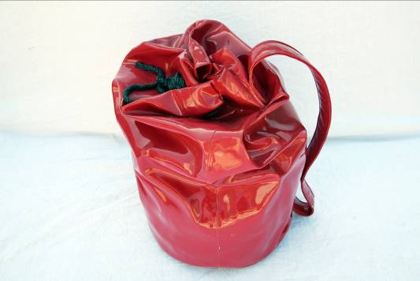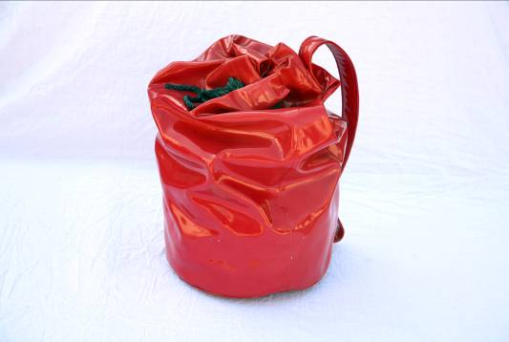
Red Plastic Bag, 43x30x56cm, bronze,2008

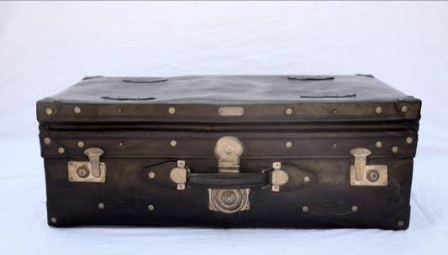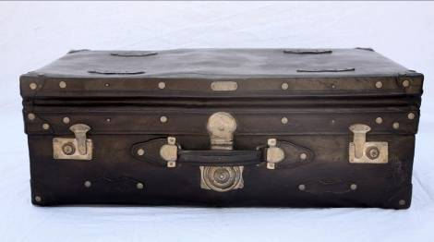
Big Brown Suitcase, 75x41x26cm, , bronze, 2008

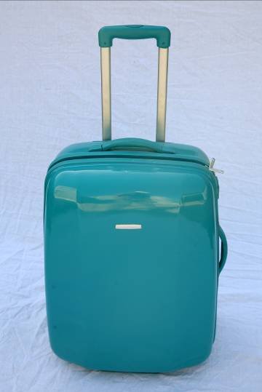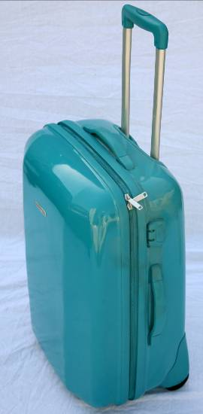
Light Blue Stroller, 44x25x83cm, bronze, 2008

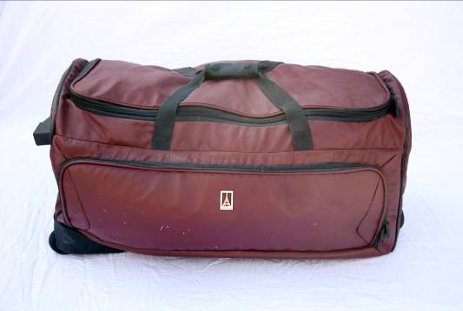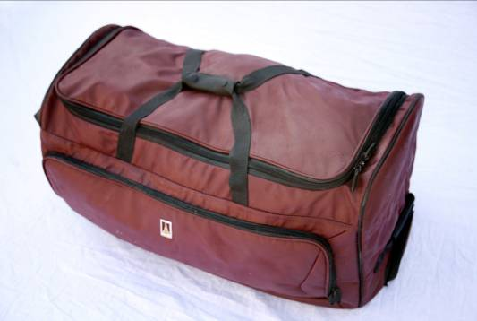
Dark Red Bundle Bag, 76x45x36cm ,bronze, 2008

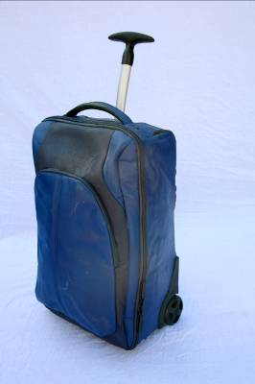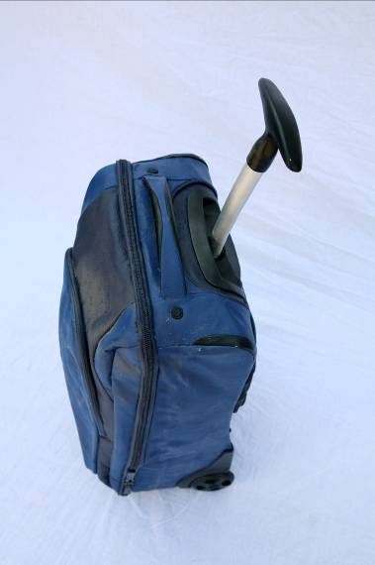
Black and Blue Stroller, 34x28x73cm, bronze, 2008

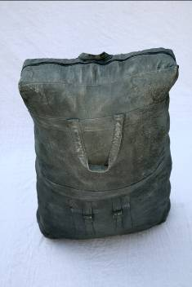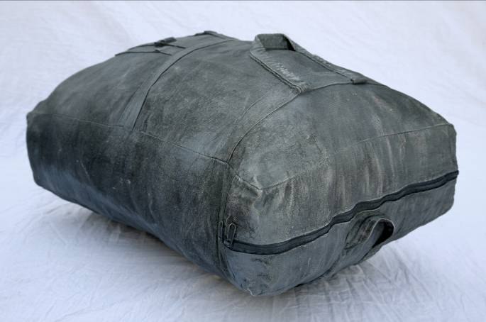
Denim suitcase, 53x38x75cm, bronze, 2008

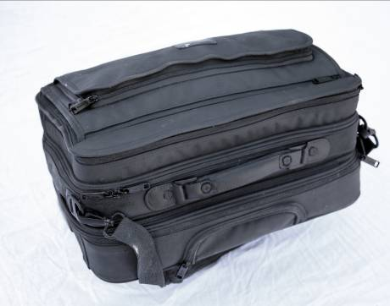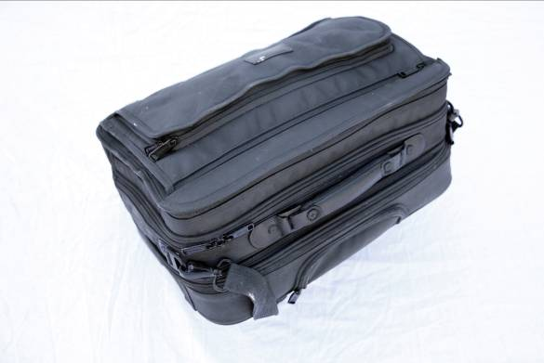
Black Computer Bag, 50x38x39cm, bronze, 2008

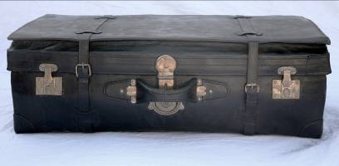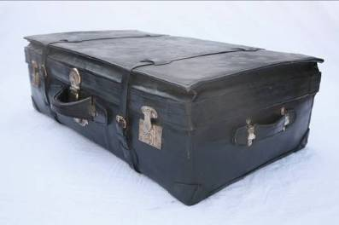
Big Black Suitcase, 88x57x27cm, bronze, 2008

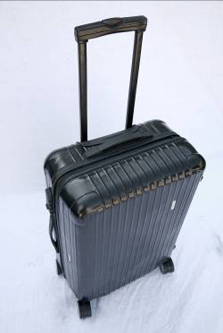
Black Rimova Suitcase, 43x24x95cm, 2008

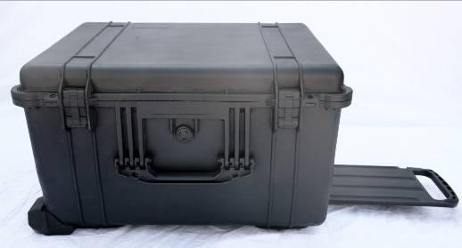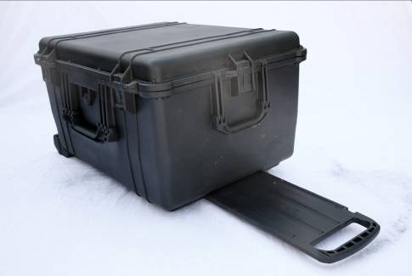
Big Black Photography Suitcase, 48x35x90cm, 2008

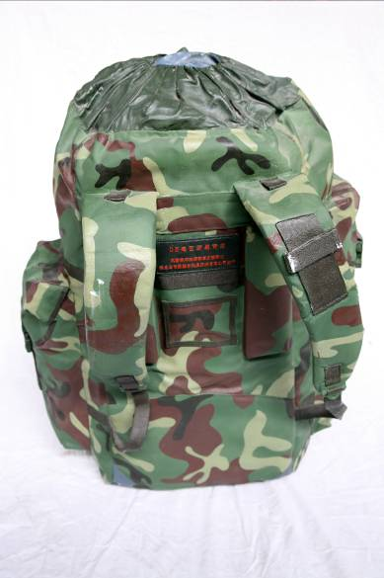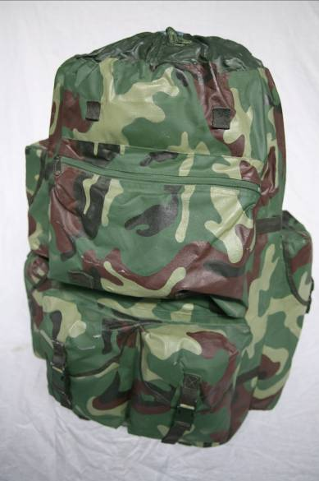
Camouflage suitcase, 56x55x75cm, bronze, 2008

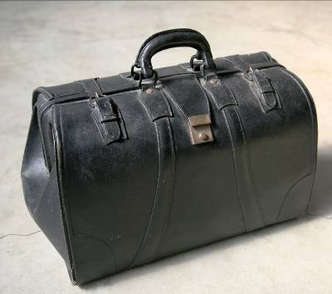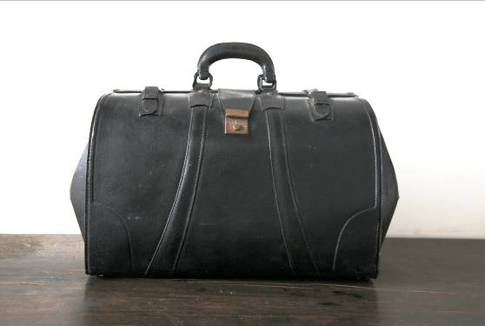
Black Shanghai-style Handbag, 55x23x40cm, bronze, 2008

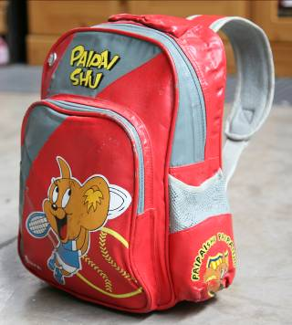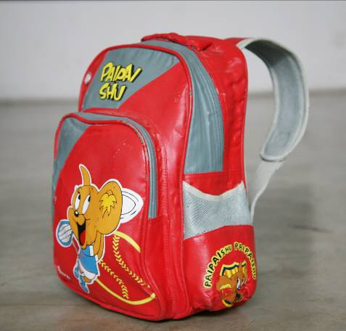
Micki’s Schoolbag, 36x35x36cm, bronze, 2008

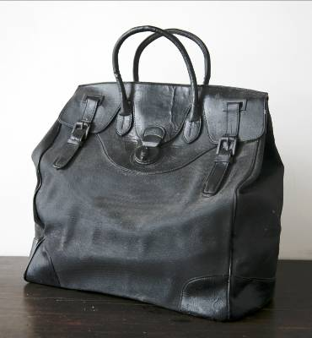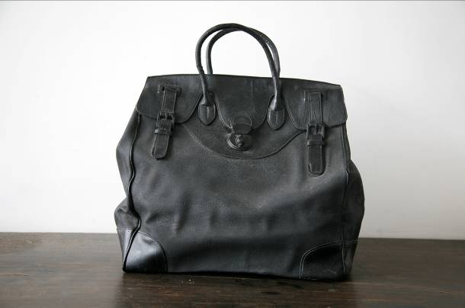
Black Modern Handbag, 50x24x48cm, bronze, 2008

